EENG 284

–

Digital Design Lab

How To: Perform a Simulation

**Performing a Simulation**

If you are planning on performing a simulation of your design then the top level entity should be a testbench. Inside the testbench should be an instantiation of your design as the unit under test.

1. Click on the Files tab in the *Project Navigator* pane.
2. Right click on *topLevelProjectFile.v* in the *Project Navigator* pane and select Set as Top-Level entity.
3. Click on the Hierarchy tab in the *Project Navigator* pane.
4. In the main Quartus II window, click on *Processing -> Start -> Start Analysis & Elaboration.* This may take some time, so be patient.
5. You can close the compilation report by clicking on the x in the red box,
6. You should see *topLevelProjectFile.v* as the root entity in the Hierarchy tab in the *Project Navigator* pane.
7. In the main Quartus II window, click *Tools -> Run Simulation Tool -> RTL Simulation*. The ModelSim program will launch. This may take a few moments, be patient.
8. In ModelSim, find the *Library* pane. Expand the *work* library by clicking on the “+” at left. Right click on *topLevelProjectFile* and click *Simulate*.
9. In the sim pane, right mouse click on uut and select *Add Wave*.

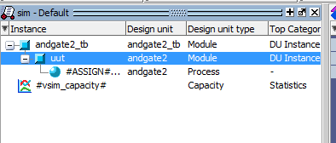

1. Choose *Simulate -> Run -> Run 100*. You should see inputs and output from *topLevelProjectFile*.
2. If you are asked to save the waveform. Perform the following steps:
   1. Undock the Wave pane by clicking the undocking tool icon.

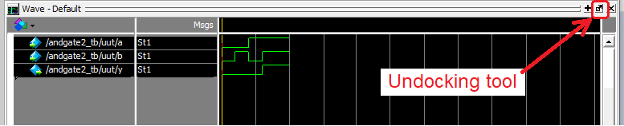

* 1. Resize the undocked Wave window vertically by grabbing its top edge and dragging down. Make the window tall enough to fit all the waves with a little room to spare.

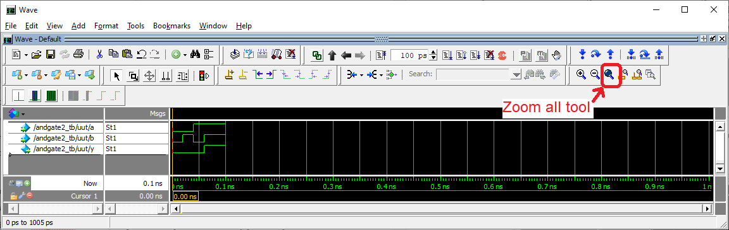

* 1. Click the Zoom all tool to file the available horizontal space with the waveform.
  2. Re-order the waves so that the inputs are highest and outputs are lowest. Do this by grabbing their name and dragging it to the correct location.
  3. Color the intermediate signals (p1, p2, p4, p7) yellow by right clicking on them, selecting properties. In the View tab of the Wave Properties pop-up, click the Colors… button for Wave Color and choose Yellow, click Close, then OK.
  4. Color the output signals red. Leave the input signals green.
  5. Click File -> Export -> Image
  6. Navigate to your project directory, provide a File name, then click Save

1. Close ModelSim. Do not save wave commands.